Inrush Current in DC-DC Converters
DC-DC 转换器中的浪涌电流
September 22, 2008 Item MediaArticles, Design, EMC Test & Design Guide, Filters / Ferrites, Lightning & Surge
Some applications may require limiting the inrush spike into the input capacitors.
某些应用可能需要限制输入电容的浪涌尖峰。
Steve Butler and Jeremy Ferrell, VPT, Inc., Blacksburg, Virginia, USA
BACKGROUND
背景
Inrush current is the spike of current drawn by a power supply when it is turned on. A typical power system is shown in Figure 1. The input EMI filter will include some capacitance connected across the input line. The DC-DC converter will also include capacitance connected across its input and output. The load may include additional capacitance. Each of these capacitors requires current to charge them to their steady state voltage. This current is the inrush current.
浪涌电流是电源打开时吸收的电流尖峰。典型的电源系统如图1所示。输入EMI滤波器将包括一些连接在输入线路上的电容。DC-DC转换器还将包括连接在其输入和输出上的电容。负载可能包括额外的电容。这些电容器中的每一个都需要电流才能将它们充电至稳态电压。该电流就是浪涌电流。
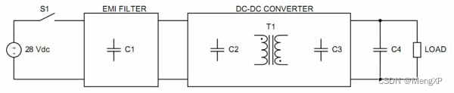
Figure 1. Typical power system showing relevant capacitances.
图1.显示相关电容的典型电源系统。
Large inrush currents might be governed by a system level specification. There is a concern that high spike currents can create electromagnetic interference in adjacent circuitry, or trip an upstream circuit breaker or the over-current protection of a solid state power controller.
大浪涌电流可能受系统级规范的约束。人们担心高尖峰电流会在相邻电路中产生电磁干扰，或使上游断路器或固态电源控制器的过流保护跳闸。
INRUSH CURRENT WAVEFORM
浪涌电流波形
A typical inrush current waveform is shown in Figure 2. It has two current peaks. The first “inrush spike” peak current occurs when the input voltage source is turned on. This peak current flows into the EMI filter capacitors and the input capacitor of the DC-DC converter, charging them to their steady state value. The second current peak occurs when the DC-DC converter turns on. This peak current flows through the power transformer in the DC-DC converter to the output capacitor and into any load capacitance, charging them to their steady state value.
典型的浪涌电流波形如图2所示。它有两个电流峰值。第一个“浪涌尖峰”峰值电流发生在输入电压源导通时。该峰值电流流入EMI滤波电容器和DC-DC转换器的输入电容器，并将它们充电至稳态值。第二个电流峰值出现在 DC-DC 转换器导通时。该峰值电流流经DC-DC转换器中的电源变压器，流向输出电容器和任何负载电容，并将它们充电至稳态值。
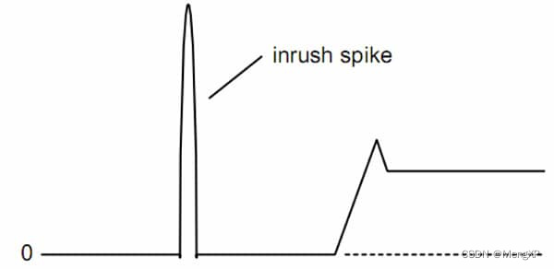
Figure 2. Typical inrush current waveform.
图2.典型浪涌电流波形。
INRUSH SPIKE CURRENT
浪涌尖峰电流
The first current peak is often referred to as the inrush spike. Its peak value and shape are highly dependent on the characteristics of the input source, specifically the voltage rise time and source impedance. A fast rising input voltage waveform, such as from a mechanical switch closure, will produce a very high and narrow current peak. A slower rising input waveform, such as from the output of some upstream electronics or a capacitor bank, will produce a lower, more controlled peak.
第一个电流峰值通常称为浪涌尖峰。其峰值和形状高度依赖于输入源的特性，特别是电压上升时间和源阻抗。快速上升的输入电压波形（例如来自机械开关闭合的波形）将产生非常高且窄的电流峰值。较慢的上升输入波形，例如来自某些上游电子设备或电容器组的输出，将产生更低、更可控的峰值。
The peak value of the inrush current is determined by the equation, i=C*dv/dt. The capacitance is the total capacitance of the EMI filter and the input capacitance of the DC-DC converter. The dv/dt is the slope of the applied voltage waveform. This inrush spike is only an issue if the input voltage source has a very fast rise time. Normally the only thing that can produce a fast enough rise time is a mechanical switch or relay closure. If the source is a switching power converter, solid state power controller, or capacitor bank, the rise time will usually be much slower. Switching power converters usually have output voltage rise times on the order of a few milliseconds, solid state power controllers (SSPC) usually from 50us to 500us, and large capacitor banks usually cannot be charged in less than several milliseconds. These slow rise times will not produce excessively high current peaks. It is also important to evaluate not only the peak current, but the i2t of the current waveform to determine if an upstream fuse, circuit breaker or SSPC will trip due to inrush current.
浪涌电流的峰值由公式i=C*dv/dt确定。电容是EMI滤波器的总电容和DC-DC转换器的输入电容。dv/dt 是施加的电压波形的斜率。只有当输入电压源的上升时间非常快时，这种浪涌尖峰才是一个问题。通常，唯一能产生足够快的上升时间的是机械开关或继电器闭合。如果电源是开关电源转换器、固态电源控制器或电容器组，则上升时间通常会慢得多。开关电源转换器的输出电压上升时间通常为几毫秒，固态电源控制器（SSPC）通常在50us至500us之间，大型电容器组通常不能在几毫秒内充电。这些缓慢的上升时间不会产生过高的电流峰值。同样重要的是，不仅要评估峰值电流，还要评估电流波形的i2t，以确定上游保险丝、断路器或SSPC是否会因浪涌电流而跳闸。
TURN ON CURRENT
开机电流
The second current peak of Figure 2 is also considered part of the inrush current. This peak occurs when the DC-DC converter turns on and draws current from the input to charge its output capacitance and any load capacitance. Typical turn-on current waveforms are shown in Figure 3. The turn-on current is the same whether the converter is turned on by applying the input voltage or via the inhibit signal.
图2的第二个电流峰值也被认为是浪涌电流的一部分。当 DC-DC 转换器导通并从输入端吸取电流以对其输出电容和任何负载电容充电时，会出现此峰值。典型的导通电流波形如图3所示。无论转换器是通过施加输入电压还是通过抑制信号导通，导通电流都是相同的。
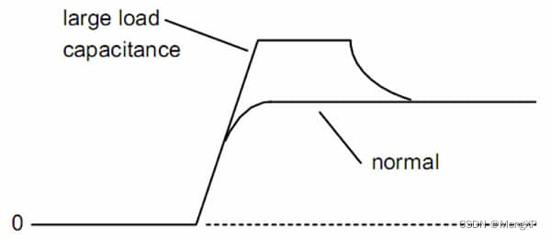
Figure 3. Typical turn-on current waveform.
图3.典型导通电流波形。
VPT’s DC-DC converters utilize a proprietary a magnetic feedback scheme with a well controlled internal start-up sequence and a precise output voltage soft start feature. The voltage soft start feature ensures the output ramps up in a controlled manner, with limited dv/dt. Due to the soft start, the input current usually does not exceed the steady state input current of the converter during turn-on, see the normal curve shown in Figure 3.
VPT 的 DC-DC 转换器采用专有的磁反馈方案，具有控制良好的内部启动顺序和精确的输出电压软启动功能。电压软启动功能可确保输出以受控方式斜坡上升，且 dv/dt 有限。由于采用软启动，导通时输入电流通常不超过转换器的稳态输入电流，参见图3所示的正常曲线。
VPT’s DC-DC converters also feature continuous constant output current limit. They will supply full rated current into any load, they do not hiccup or shut down and restart. This allows them to start any load capacitor, regardless of size. For cases with very large load capacitance, the DC-DC converter might enter this constant current limit mode during turn-on. In this case the input current would not exceed approximately 1.5 times the steady state input current, see the large load capacitance curve in Figure 3. This is not high enough to cause any interference or trip upstream protection devices. For VPT’s DC-DC converters, this second inrush peak will not cause adverse effects in the system design.
VPT 的 DC-DC 转换器还具有连续恒定输出电流限制。它们将为任何负载提供全额定电流，不会打嗝或关闭并重新启动。这允许它们启动任何负载电容器，无论大小如何。对于负载电容非常大的情况，DC-DC转换器可能会在导通期间进入此恒流限制模式。在这种情况下，输入电流不会超过稳态输入电流的约1.5倍，参见图3中的大负载电容曲线。这不足以造成任何干扰或跳闸上游保护设备。对于VPT的DC-DC转换器，第二个浪涌峰值不会对系统设计造成不利影响。
ACTIVE INRUSH LIMITING
主动浪涌限制
In some applications there is a requirement to limit the inrush spike current into the input capacitors. The only way to do this is to insert a series element into the circuit in front of those capacitors. Figure 4 shows a very basic inrush limiting circuit. The series resistor R1 will limit the input current until the input capacitors are charged. The relay S1 will then close to allow the full current to flow to the downstream DC-DC converter. The relay coil can be driven from the 28V input such that it will be somewhat automatically controlled.
在某些应用中，需要限制输入电容器的浪涌尖峰电流。唯一的方法是在这些电容器前面的电路中插入一个串联元件。图4显示了一个非常基本的浪涌限制电路。串联电阻R1将限制输入电流，直到输入电容充电。然后继电器 S1 将闭合，以允许全部电流流向下游 DC-DC 转换器。继电器线圈可以从28V输入驱动，以便在某种程度上自动控制。
Figure 4. Discrete active inrush current limiting circuit using a series resistor.
图4.采用串联电阻的分立式有源浪涌电流限制电路。
An inductor could also be used to limit inrush current. It would not need to be bypassed since it can carry DC current with low loss. However a large inductance value is usually required to limit the inrush sufficiently. Care must be taken since this inductor can ring with the input filter or can interact with the DC-DC converter’s internal feedback loop, causing system instability. Additional components are usually necessary to damp the resulting resonance.
电感器也可用于限制浪涌电流。它不需要旁路，因为它可以以低损耗承载直流电流。然而，通常需要较大的电感值来充分限制浪涌。必须小心，因为该电感可能会与输入滤波器振铃或与DC-DC转换器的内部反馈环路相互作用，从而导致系统不稳定。通常需要额外的组件来抑制产生的共振。
Another practical circuit is shown in Figure 5. This circuit uses a series MOSFET Q1 placed in the negative power lead. Q1 is normally off, with its gate pulled low through R2. When input voltage is applied, the gate will charge through R1. The charge time and turn-on of Q1 will be slowed by C1. R1 and C1 can be chosen to allow the input capacitors to charge slowly, limiting the inrush current. After the input capacitors are charged, the gate of Q1 will charge until it is limited by the zener and Q1 will remain fully on.
另一个实用电路如图5所示。该电路使用串联MOSFET Q1放置在负功率引线中。Q1 通常关闭，其栅极通过 R2 拉低。当施加输入电压时，栅极将通过R1充电。Q1的充电时间和导通速度将减慢C1。可以选择R1和C1，以允许输入电容缓慢充电，从而限制浪涌电流。输入电容充电后，Q1的栅极将充电，直到受到齐纳二极管的限制，Q1将保持完全导通。
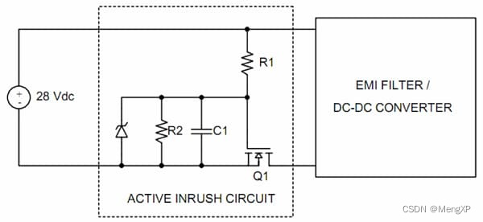
Figure 5. Discrete active inrush current limiting circuit using a series MOSFET.
图5.采用串联MOSFET的分立式有源浪涌电流限制电路。
This circuit can be modified with Q1 located in the positive lead. It can be driven in the same manner by using a P-channel MOSFET. Or it can use an N-channel MOSFET but with the gate driven by a charge pump or isolated supply. Various other active inrush limiting circuits exist. They all use some series device in the input power leads and act in approximately the same way. It is always important that once the input capacitors are charged, the series device is bypassed or turned fully on to limit line impedance and power dissipation. It is also important that the active inrush control not introduce any noise into the input line since it is located upstream of the EMI filter.
该电路可以通过位于正极引线中的Q1进行修改。通过使用P沟道MOSFET，可以以相同的方式驱动它。或者，它可以使用 N 沟道 MOSFET，但栅极由电荷泵或隔离电源驱动。存在各种其他主动浪涌限制电路。它们都在输入电源引线中使用一些串联器件，并且工作方式大致相同。输入电容充电后，串联器件被旁路或完全导通以限制线路阻抗和功耗始终很重要。同样重要的是，有源浪涌控制不会将任何噪声引入输入线路，因为它位于EMI滤波器的上游。
INPUT MODULES WITH INRUSH LIMITING
带浪涌电流限制的输入模组
Several of VPT’s input modules include built-in inrush current limiting. They are listed in Table 1. These modules each use a series N-channel MOSFET in the positive lead. The N-channel MOSFET achieves the lowest ON-state resistance to minimize power losses. Locating it in the positive lead leaves the return path unbroken, simplifying system design. And, this series MOSFET is used for a dual purpose in these modules; it also provides input voltage transient protection.
VPT 的几个输入模块包括内置浪涌电流限制。它们列在表 1 中。这些模块均在正极引线上使用串联 N 沟道 MOSFET。N 沟道 MOSFET 实现了最低的导通状态电阻，从而将功率损耗降至最低。将其定位在正极引线上可使返回路径不间断，从而简化系统设计。而且，该系列MOSFET在这些模块中具有双重用途;它还提供输入电压瞬态保护。
The DV-704A or DVMN28 contain both an EMI filter and inrush limiting. The two circuits are optimized to work together. The inrush circuit limits any current flowing into the EMI capacitors, but does not introduce any additional EMI into the input lines, as is possible with a discrete circuitry. The VPTPCM-12 contains inrush limiting circuitry which will limit inrush current into its capacitors and those of downstream DC-DC converters. But it also contains switching elements, so it may require additional unprotected EMI filtering at its input.
DV-704A 或 DVMN28 包含 EMI 滤波器和浪涌限制。两个电路经过优化，可以协同工作。浪涌电路限制流入EMI电容器的任何电流，但不会将任何额外的EMI引入输入线路，这就像分立电路一样。VPTPCM-12 包含浪涌限制电路，可限制进入其电容器和下游 DC-DC 转换器的浪涌电流。但它也包含开关元件，因此可能需要在其输入端进行额外的无保护EMI滤波。
CONCLUSION
结论
Inrush current is the peak current which flows into the power converter when input voltage is applied or at turn-on. Most system inrush current specifications will be met with VPT’s DC-DC converters alone. Some applications may require limiting the inrush spike into the input capacitors. This will require additional circuitry, or one of VPT’s input modules with built-in inrush limiting.
浪涌电流是施加输入电压或导通时流入功率转换器的峰值电流。大多数系统浪涌电流规格仅使用 VPT 的 DC-DC 转换器即可满足。某些应用可能需要限制输入电容的浪涌尖峰。这将需要额外的电路，或者VPT的输入模块之一，内置浪涌限制。
ABOUT THE AUTHOR
关于作者
Steve Butler is Vice President of Engineering and Jeremy Ferrell is a Senior Design Engineer at VPT, Inc. in Blacksburg, Virginia. VPT is a vendor of DC-DC converter and EMI filter modules and can be reached ad www.vpt-inc.com.
Steve Butler 是工程副总裁，Jeremy Ferrell 是弗吉尼亚州布莱克斯堡 VPT， Inc. 的高级设计工程师。VPT是DC-DC转换器和EMI滤波器模块的供应商，可以通过以下方式获得www.vpt-inc.com.

